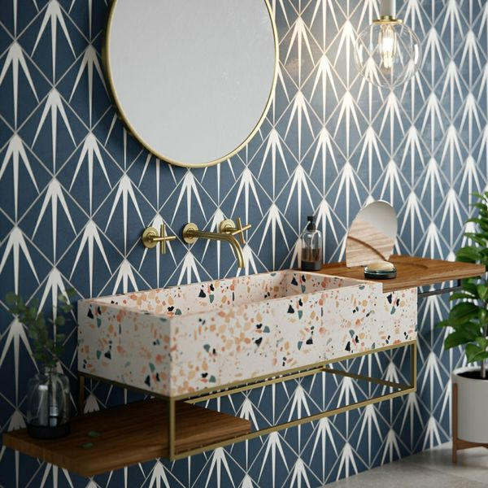**Gatsby Marine Tiles:**

## **Product Description**

With their ornate encaustic appearance, our Gatsby Tiles are perfect for creating a statement wall or floor space in your home. Turn the tiles in different directions to create a multitude of captivating patterns.

**What's special about these tiles?**

> Sought after patterned design

> Perfect for creating a bespoke statement

> Ideal for use on a wall or floor

## **Product Info**

* Product ID: 44604
* Tiles Per SQM: 25
* Sale by: Per SQM
* Size: 200x200x8mm
* Weight: 0.74 KG
* Material Type: Porcelain
* Finish: Matt
* Colour: Blue
* Suitability: Floors, Walls
* Grade: 3
* Rectified Edge: No
* Underfloor Heating: Yes
* Thickness (mm): 8